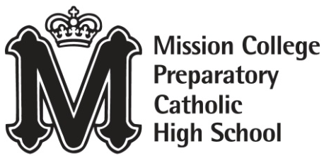
Purchase Order # 500

682 Palm Street
San Luis Obispo, CA 93401
Tax ID # 94-1658139 Date: 5/23/2022

TO: Tech to School
1530 Montague Expwy
San Jose, CA 95131

RE: Chromebook Order TTS1578

Description | Quantity | Unit Price | Extended Price
Lenovo 14E Chromebook 14” (New in Box) | 30 | $259.00 | $7770.00
 |  | Discount
 |  | Shipping and Tax | $563.33
 |  | Total | $8,333.33

Please direct any inquiries to Carlesha Harris, Business Manager
caharris@missionprep.org / 805-543-2131

